**Task 6: Change Detection**

Implementation of change detection

1. Make courses list component smart to handle all the logic.
2. Each course item component should be dumb with onPush strategy. ([useful link](https://blog.angular-university.io/angular-2-smart-components-vs-presentation-components-whats-the-difference-when-to-use-each-and-why/))
3. Enable AOT
4. Fix issues in the templates that revealed after enabling AOT

Course add/edit page markup + basic structure

1. Create add course page. (don’t need to create routing. Do the same as for login page)
2. Create markup and simple model for add course page. Use binding for every field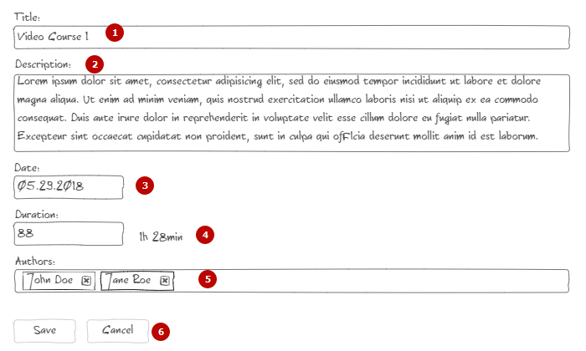
   1. Text input
   2. Text area
   3. Separate component. Text input for now.
   4. Separate component. Input in minutes. Eval duration aside of input with pipe created before.
   5. Separate component. Skip it for now.
   6. Buttons block. Add empty handlers.

Criteria for evaluation

1. Nothing changed
2. Partially done with critical issues. Not working.
3. Done with some issues. AOT enabled.
4. All above with markup implemented. Some issues.
5. Done all above without major issues

Extra task:

Taking in view changed change detection strategy your tests should fail. Fix all issues related to this changes